**Assignment No 6 [1]**

**Question:** Explain the Architecture of Git?

**Solution:**

**Git Architecture**

Git is a distributed version control system designed to handle everything from small to very large projects with speed and efficiency.

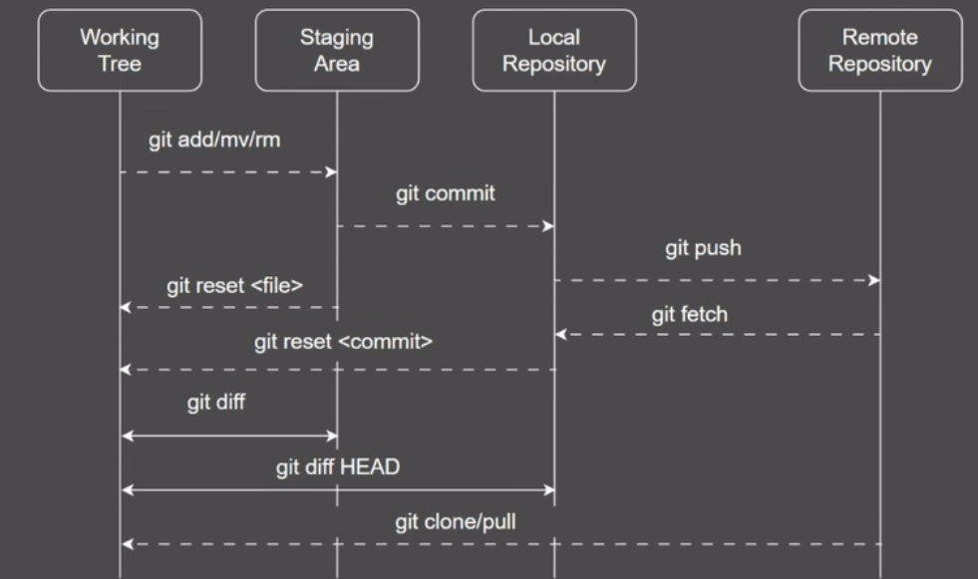

The architecture of Git consists of several key components and concepts:

1. **Working Directory:**

This represents the current directory and files you are working on. This is where you make changes to your code or files.  
  
**git add/mv/rm**: These commands allow you to stage changes. git add stages new changes, git mv stages file renames, and git rm stages file deletions.  
  
**git diff**: This shows differences between the working tree and the staging area.  
  
**git diff HEAD**: This shows differences between the working tree and the last commit in the local repository.

1. **Staging Area:**

After you make changes in the working tree, you can stage them (i.e., prepare them for a commit).  
  
 The staging area is an intermediate area where these changes are stored before they are permanently stored in the local repository.  
  
**git commit**: This command moves changes from the staging area to the local repository, creating a new commit.

1. **Local Repository:**

This is where your commits are stored on your local machine.  
  
**git reset <file>:** This command un-stages changes, moving them from the staging area back to the working tree.  
  
**git reset <commit>**: This can be used to undo commits or change the current branch's head to a specific commit.

1. **Remote Repository:**

This represents an online (or network) storage location where you store versions of your project. It's useful for collaborating with others and backing up your work.  
  
**git push**: This command pushes changes from your local repository to the remote repository.  
  
**git fetch**: This fetches changes from the remote repository without integrating them.  
  
**git clone/pull**: git clone copies the remote repository to your local machine. git pull fetches changes from the remote repository and merges them into your current branch.